**SQL ASSIGNMENT 10**

Q1. Write an SQL query to determine the 5th highest salary without using TOP or limit method.

**Solution:**

Step-1. Select first_name, salary from workers wrk1 where 5-1 = (select count (distinct salary) from workers wrk2 where wrk2.salary>wrk1.salary)

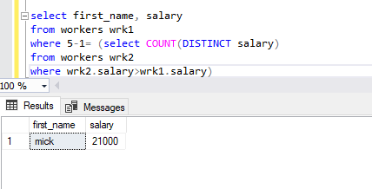

Q2. Write an SQL query to fetch the list of employees with the same salary.

**Solution:**

Step-2. Select * from workers where salary IN ( select salary from workers GROUP BY salary having count(*)>1) order by salary DESC;

